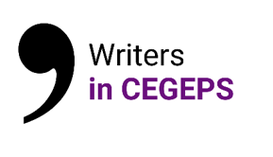

Attention: Due to limited funds for this program, we may not be able to fulfill all requests in the academic year. To ensure that funds are still available for your visit, please send the completed version of this form at least one month before the visit.

Name of CEGEP:

Address:

Person at the CEGEP responsible for writers’ visits:

Office phone number: Home phone number:

Email address:

Writer requested:
D____/M_____/Y______
Date and time set for the visit (after having confirmed with the writer in question) :
Activity proposed:
Lecture and reading

Writing workshop

Webinar

The CEGEP undertakes to pay $ 100 directly to the writer at the time of the visit and to publicize the visit:

D____/M_____/Y______

Signature: Date:

You will receive confirmation by email within a week following the receipt of your request.
Please return this application form to:

UNEQ
Att. Noémie Payette-Gonthier
noemie.gonthier@uneq.qc.ca
(514) 849-8540 ext. 225 | Fax: (514) 849-6239

For information about eligible writers, follow the link to the online list of writers at www.qwf.org/programs or contact the Quebec Writers' Federation at (514) 933-0878.

